Lifton Benefice  online  Advent Calendar  5th December 2020 | 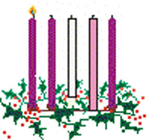
A Grave puzzle
Answers:

1: St Pauls
2: Norwich
3 Leicester
4: St. Albans
5: Durham
6: Portsmouth
7: Winchester
8: Southwark

